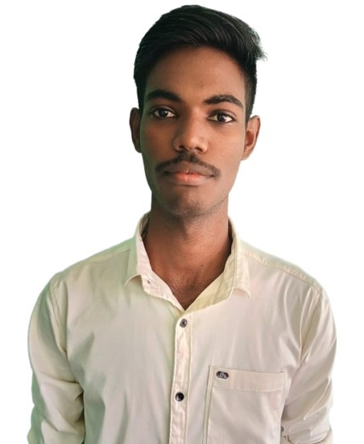SATHEESHKUMAR T

**Phone** : 8124402004

**Email :** [sathisatheesh2843@gmail.com](mailto:sathisatheesh2843@gmail.com)

**LinkedIn** : https:/[/w](http://www.linkedin.com/in/satheeshkumar-t-a58104249/)w[w.linkedin.com/in/satheeshkumar-t-a58104249/](http://www.linkedin.com/in/satheeshkumar-t-a58104249/)

**GitHub :** https://github.com/satheesh2843

**Address** : 71, Arasamarathottam, Karattupalayam, Erode Dist., Tamil Nadu.



## CAREER OBJECTIVE

To look forward for an opportunity to apply my knowledge with group of motivated individuals who wish to work towards the advancement of the company and its goals.

**EDUCATIONAL QUALIFICATION**

|  |  |  |  |
| --- | --- | --- | --- |
| **Qualification** | **Institutions** | **Marks in CGPA/percentage** | **Year OF PASSING** |
| B. E. **ELECTRONICS AND COMMUNICATION ENGINEERING** | Karpagam Academy of Higher Education | 8.07  (up to 4 semester) | 2025  (pursuing) |
| HSC | Komarsamy Gounder Matriculation Higher Secondary School | 86.46 | 2021 |
| SSLC | Komarsamy Gounder Matriculation Higher Secondary School | 80.2 | 2019 |

**PROJECT**

**Density based traffic control system using Arduino:**

To regulate traffic flow based on vehicle density. By dynamically adjusting signal timings, it helps manage congestion and maintain a steady flow of vehicles.

## INTERNSHIP

* Undergone an internship in Python by Pantech e learning for 15 days
* Undergone an internship in Java by Vault of Code for 30 days

**CERTIFICATION**

* Certified in startup Idea from Galgotias University in Noida s.
* Certified in Introduction to Cyber Security from Infosys.
* Certified in Decision Trees using Python from Infosys.
* Certified in Introduction to Python from Infosys
* Certified in Introduction of Artificial Intelligence from Infosys
* Certified in Introduction of Artificial Intelligence from Infosys
* Certified Molecular Basis of Inheritance from Infosys
* Certified Data Analysis with Python from IBM
* Certified Introduction to C from Solo learn.

## WORKSHOPS

* Attended a workshop in Embedded System using Arduino UNO conducted by Karpagam College of Engineering
* Attended Mobile Services Workshop conducted by Mobile Serives
* Attended Advances in Optical Communication organized conducted by IIT Madras

**AREA OF INTEREST**

* Programming
* Web development

## TECHNICAL SKILLS

* C.
* Java (pursuing).
* Python (pursuing).
* MS Office.
* HTML.
* CSS.
* SQL.

# STRENGTH

* Communication
* Effective Planning.
* Team work

# Declaration

I hereby declare that the information stated above is true to the best of my knowledge.

Place:

Date:

## [SATHEESHKUMAR T]